#1.A) BASIC PRACTICE EXPERIMENTS 1-4

#230701004

#ABHINAYA LAKSHMI.S

#30/07/24

import pandas as pd

import matplotlib.pyplot as plt

data = {‘Year’: list(range(2010, 2021)),

‘Job Postings’: [150, 300, 450, 600, 800, 1200, 1600, 2100, 2700, 3400, 4200]}

df = pd.DataFrame(data)

plt.plot(df[‘Year’], df[‘job Postings rob Postings’], marker=‘o’)

plt.title(‘Trend of Data Science Job Postings’)

plt.xlabel(‘Year’)

plt.ylabel(‘Number of Job Postings’)

plt.show()

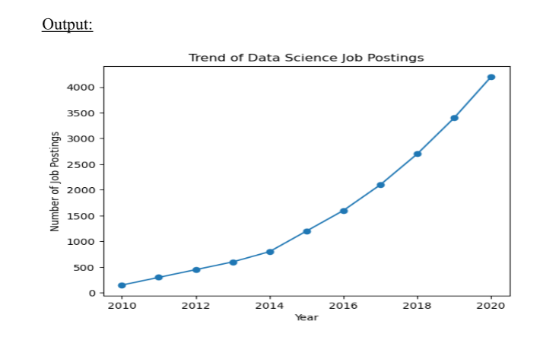

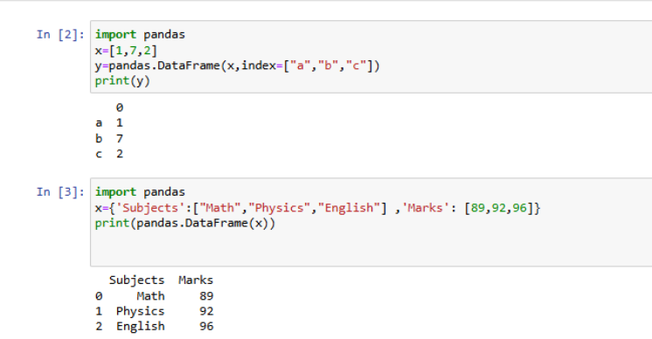

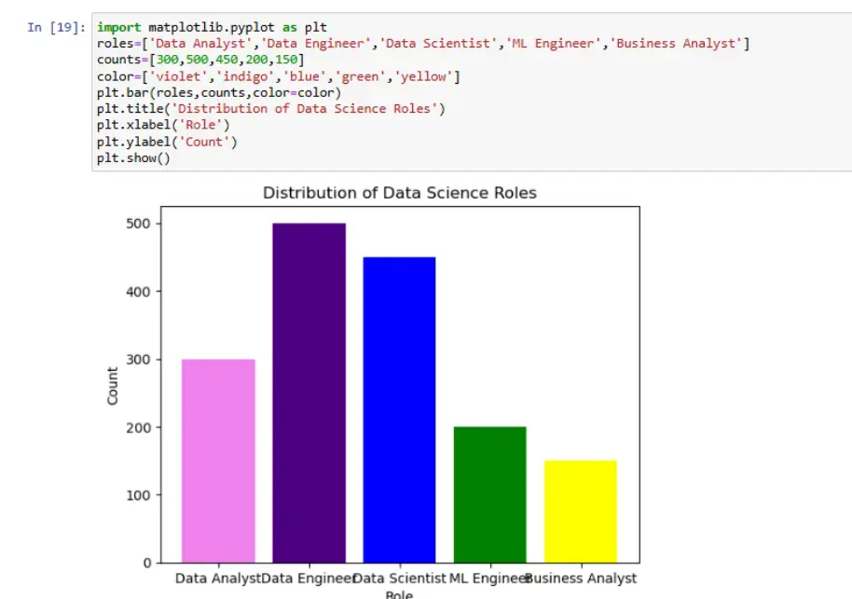

#1.B) PANDAS BUIT IN FUNCTION; NUMPY BUIT IN FUCTION- ARRAY SLICING, RAVEL,RESHAPE,NDIM

#230701004

#ABHINAYA LAKSHMI.S

#06.08.2024

#NUMPY FUNCTIONS

import numpy as np

import pandas as pd

df=pd.read_csv('Salary_data.csv')

df

df.info()

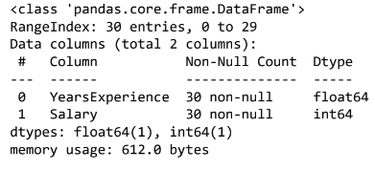

df.dropna(inplace=True)

df.info()

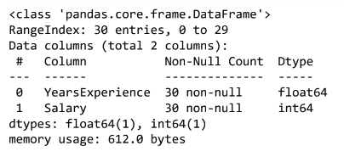

df.describe()

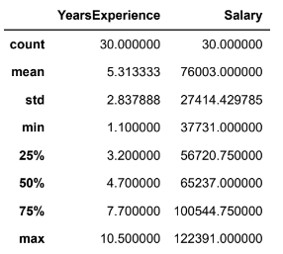

features=df.iloc[:,[0]].values

label=df.iloc[:,[1]].values

from sklearn.model_selection import train_test_split

x_train,x_test,y_train,y_test=train_test_split(features,label,test_size=0.2,random_st

from sklearn.linear_model import LinearRegression

model=LinearRegression()

model.fit(x_train,y_train)

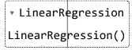

model.score(x_train,y_train)



model.score(x_test,y_test)



model.coef_



model.intercept_



import pickle

pickle.dump(model,open('SalaryPred.model','wb'))

model=pickle.load(open('SalaryPred.model','rb'))

yr_of_exp=float(input("Enter Years of Experience: "))

yr_of_exp_NP=np.array([[yr_of_exp]])

Salary=model.predict(yr_of_exp_NP)



print("Estimated Salary for {} years of experience is {}: " .format(yr_of_exp,Salary)



#PANDAS FUNCTIONS

import numpy as np

import pandas as pd

list=[[1,'Smith',50000],[2,'Jones',60000]]

df=pd.DataFrame(list)

df

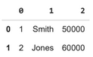

df.columns=['Empd','Name','Salary']

df

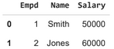

df.info()

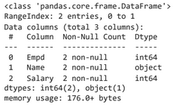

df=pd.read_csv("/content/50_Startups.csv")

df.info()

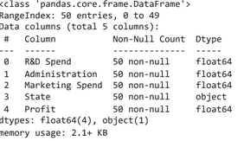

df.head()

df.tail()

import numpy as np

import pandas as pd

df = pd.read_csv(“/content/employee.csv”)

df.head()

df.tail()

df.info()

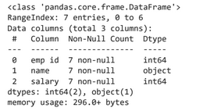

df.salary()

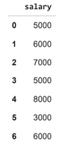

type(df.salary)

df.salary.mean()

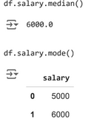

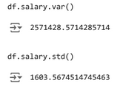

empCol=df.columns

empCol



emparray=df.values

employee_DF=pd.DataFrame(emparray,columns=empCol)

#OUTLIER DETECTION

#230701004

#ABHINAYA LAKSHMI.S

#13.08.2024

#sample calculation for low range(lr) , upper range (ur),percentile

import numpy as np

array=np.random.randint(1,100,16) # randomly generate 16 numbers between 1 to 100

array

#array([21, 72, 69, 45, 61, 43, 43, 59, 62, 42, 90, 25, 54, 86, 80, 13], dtype=int32)

array.mean()

np.percentile(array,25)

np.percentile(array,50)

np.percentile(array,75)

np.percentile(array,100)

#outliers detection

def outDetection(array):

    sorted(array)

    Q1,Q3=np.percentile(array,[25,75])

    IQR=Q3-Q1

    lr=Q1-(1.5*IQR)

    ur=Q3+(1.5*IQR)

    return lr,ur

lr,ur=outDetection(array)

lr,ur

import seaborn as sns

%matplotlib inline

sns.displot(array)

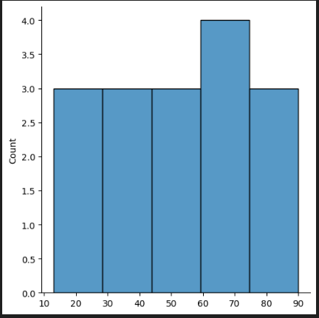

sns.distplot(array)

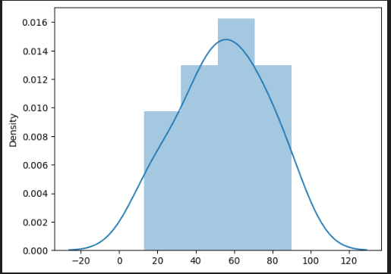

new_array=array[(array>lr) & (array<ur)]

new_array

sns.displot(new_array)

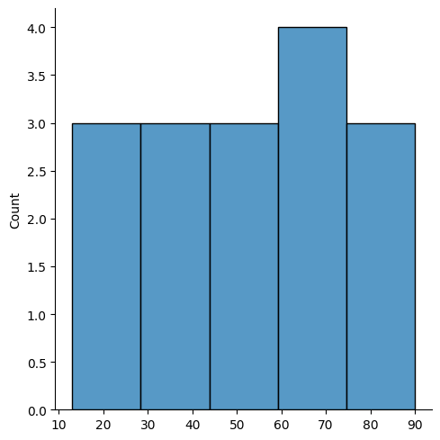

lr1,ur1=outDetection(new_array)

lr1,ur1

final_array=new_array[(new_array>lr1) & (new_array<ur1)]

final_array

sns.distplot(final_array)

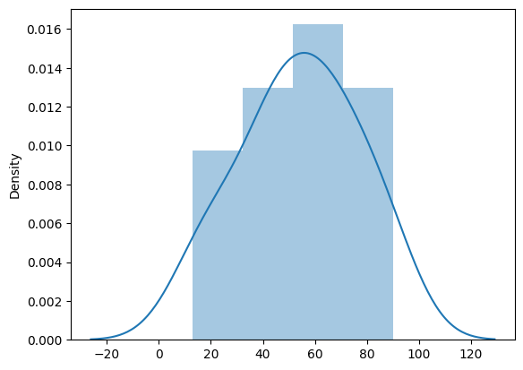

#3) Missing and inappropriate data

#230701004

#ABHINAYA LAKSHMI.S

#20.08.2024

import numpy as np

import pandas as pd

df=pd.read_csv("Hotel_Dataset.csv")

df

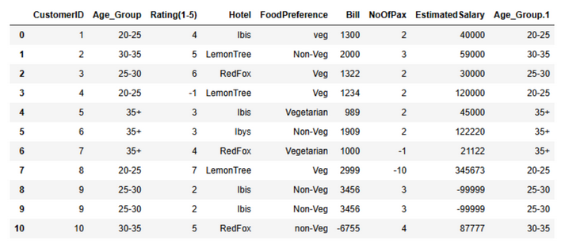

df.duplicated()

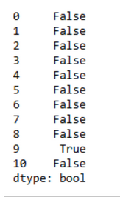

df.info()

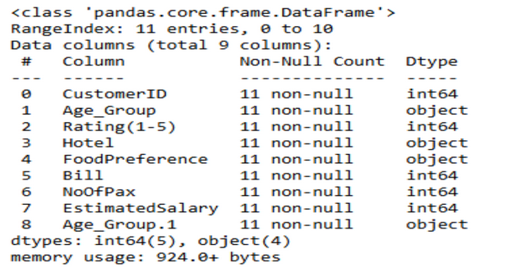

df.drop_duplicates(inplace=True)

df

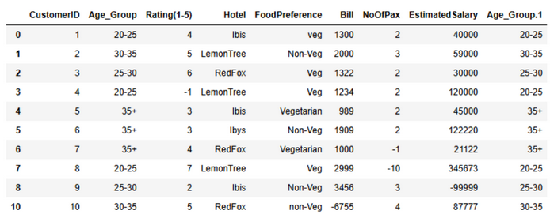

len(df)

index=np.array(list(range(0,len(df))))

df.set_index(index,inplace=True)

index

array([0, 1, 2, 3, 4, 5, 6, 7, 8, 9])

df

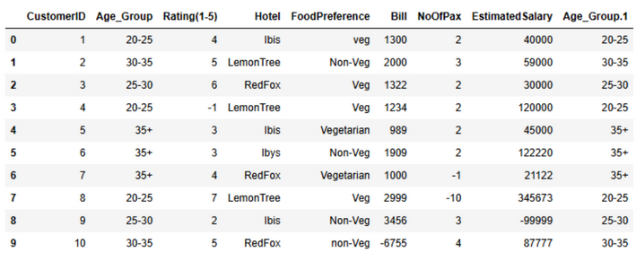

df.drop(['Age_Group.1'],axis=1,inplace=True)

df

df.CustomerID.loc[df.CustomerID<0]=np.nan

df.Bill.loc[df.Bill<0]=np.nan

df.EstimatedSalary.loc[df.EstimatedSalary<0]=np.nan

df

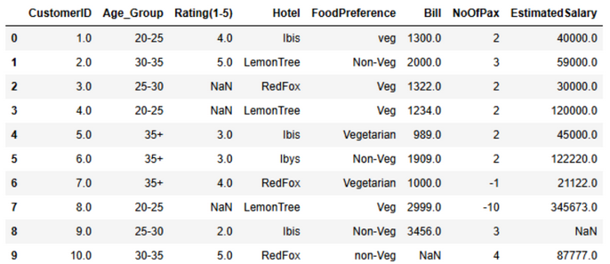

df['NoOfPax'].loc[(df['NoOfPax']<1) | (df['NoOfPax']>20)]=np.nan

df

df.Age_Group.unique()



df.Hotel.unique()



df.Hotel.replace(['Ibys'],'Ibis',inplace=True)

df.FoodPreference.unique

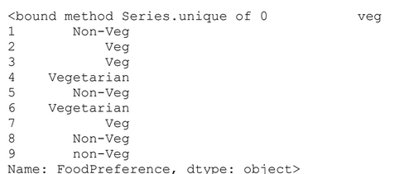

df.FoodPreference.replace(['Vegetarian','veg'],'Veg',inplace=True)

df.FoodPreference.replace(['non-Veg'],'Non-Veg',inplace=True)

df.EstimatedSalary.fillna(round(df.EstimatedSalary.mean()),inplace=True)

df.NoOfPax.fillna(round(df.NoOfPax.median()),inplace=True)

df['Rating(1-5)'].fillna(round(df['Rating(1-5)'].median()), inplace=True)

df.Bill.fillna(round(df.Bill.mean()),inplace=True)

df

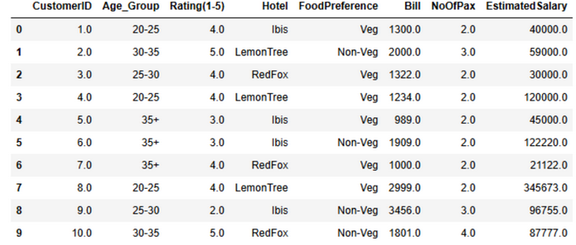

#4)Data Preprocessing

#230701004

#ABHINAYA LAKSHMI.S

#27.08.2024

import numpy as np

import pandas as pd

df=pd.read_csv("/content/pre-process_datasample.csv")

df

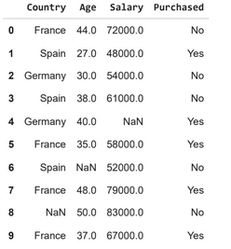

df.info()

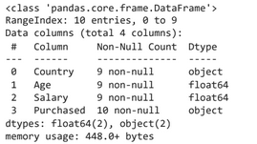

df.Country.mode()



df.Country.mode()[0]

type(df.Country.mode())

df.Country.fillna(df.Country.mode()[0],inplace=True)

df.Age.fillna(df.Age.median(),inplace=True)

df.Salary.fillna(round(df.Salary.mean()),inplace=True)

df

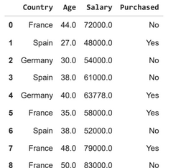

pd.get_dummies(df.Country)

updated_dataset=pd.concat([pd.get_dummies(df.Country),df.iloc[:,[1,2,3]]],axis=1)

France Germany Spain Age Salary Purchased

0 True False False 44.0 72000.0 No

1 False False True 27.0 48000.0 Yes

2 False True False 30.0 54000.0 No

3 False False True 38.0 61000.0 No

4 False True False 40.0 63778.0 Yes

5 True False False 35.0 58000.0 Yes

6 False False True 38.0 52000.0 No

7 True False False 48.0 79000.0 Yes

8 True False False 50.0 83000.0 No

9 True False False 37 0 67000 0 Yes

df.info()

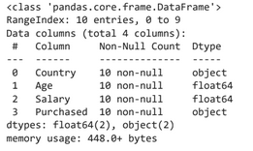

updated_dataset.Purchased.replace(['No','Yes'],[0,1],inplace=True)

updated_dataset

France Germany Spain Age Salary Purchased

0 True False False 44.0 72000.0 0

1 False False True 27.0 48000.0 1

2 False True False 30.0 54000.0 0

3 False False True 38.0 61000.0 0

4 False True False 40.0 63778.0 1

5 True False False 35.0 58000.0 1

6 False False True 38.0 52000.0 0

7 True False False 48.0 79000.0 1

8 True False False 50.0 83000.0 0

9 True False False 37.0 67000.0 1

# EDA-Quantitative and Qualitative plots - Experiments 1

#230701004

#ABHINAYA LAKSHMI.S

# 03.09.2024

import seaborn as sns

import pandas as pd

import numpy as np

import matplotlib.pyplot as plt

%matplotlib inline

tips=sns.load_dataset('tips')

tips.head()

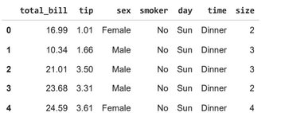

sns.displot(tips.total_bill,kde=True)

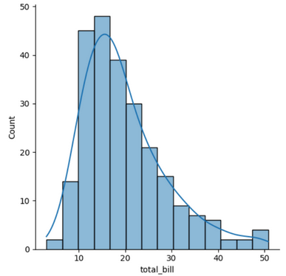

sns.jointplot(x=tips.tip,y=tips.total_bill)

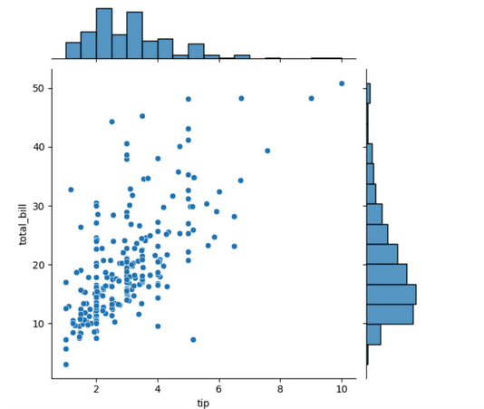

sns.jointplot(x=tips.tip,y=tips.total_bill,kind="reg")

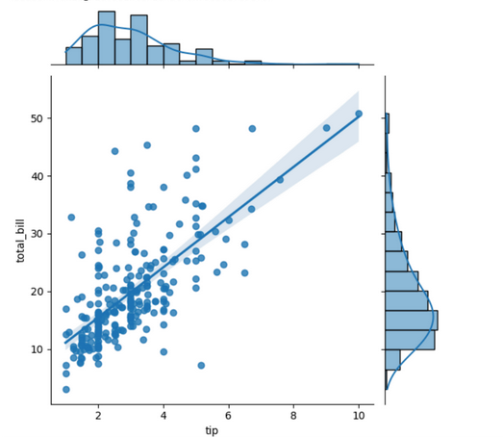

sns.jointplot(x=tips.tip,y=tips.total_bill,kind="hex")

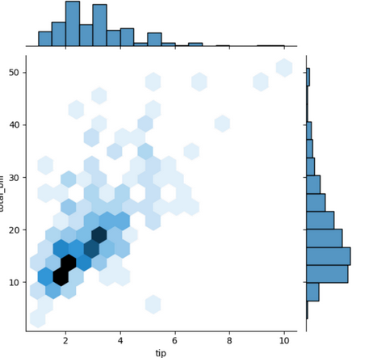

sns.pairplot(tips,hue=’time’)

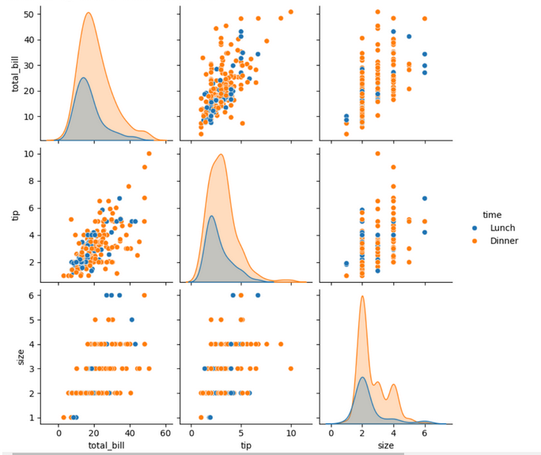

sns.heatmap(tips.corr(numeric_only=True),annot=True)

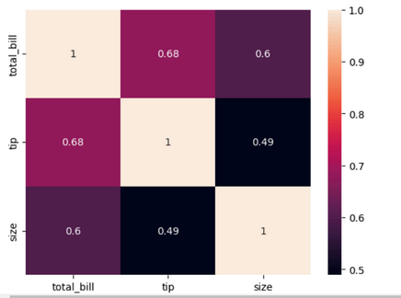

sns.boxplot(tips.total_bill)

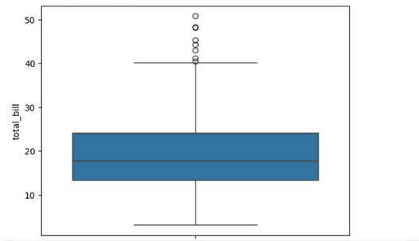

sns.countplot(tips.sex)

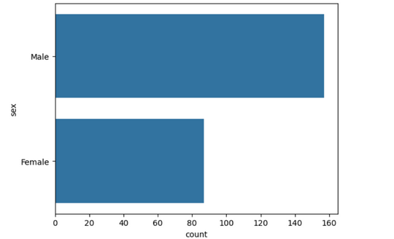

tips.sex.value_counts().plot(kind='pie')

tips.sex.value_counts().plot(kind='bar')

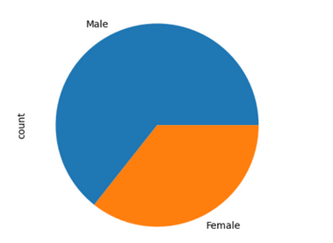

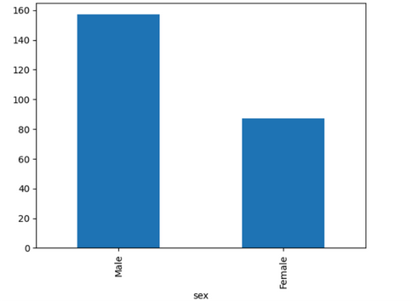

#Random Sampling and Sampling Distribution

#230701004

#ABHINAYA LAKSHMI.S

# 10.09.2024

import numpy as np

import matplotlib.pyplot as plt

population_mean = 50

population_std = 10

population_size = 100000

population = np.random.normal(population_mean, population_std, population_size)

plt.figure(figsize=(8, 5))

plt.hist(population, bins=50, color='skyblue', edgecolor='black', alpha=0.7)

plt.title('Population Distribution')

plt.xlabel('Value')

plt.ylabel('Frequency')

plt.axvline(population_mean, color='red', linestyle='dashed', linewidth=1.5, label='Population Mean')

plt.legend()

plt.show()

sample_sizes = [30, 50, 100]

num_samples = 1000

sample_means = {}

for size in sample_sizes:

sample_means[size] = []

for _ in range(num_samples):

sample = np.random.choice(population, size=size, replace=False)

sample_means[size].append(np.mean(sample))

plt.figure(figsize=(12, 8))

for i, size in enumerate(sample_sizes):

plt.subplot(len(sample_sizes), 1, i + 1)

plt.hist(sample_means[size], bins=30, alpha=0.7, color='orange', edgecolor='black',

label=f'Sample Size {size}')

plt.axvline(np.mean(population), color='red', linestyle='dashed', linewidth=1.5, label='Population Mean')

plt.title(f'Sampling Distribution of the Sample Mean (Sample Size {size})')

plt.xlabel('Sample Mean')

plt.ylabel('Frequency')

plt.legend()

plt.tight_layout()

plt.show()

plt.figure(figsize=(12, 8))

for i, size in enumerate(sample_sizes):

plt.subplot(len(sample_sizes), 1, i + 1)

plt.hist(sample_means[size], bins=30, alpha=0.7, color='purple', edgecolor='black',

label=f'Sample Size {size}', density=True)

plt.axvline(np.mean(population), color='red', linestyle='dashed', linewidth=1.5, label='Population Mean')

plt.title(f'Sampling Distribution (Sample Size {size}) - CLT Demonstration')

plt.xlabel('Sample Mean')

plt.ylabel('Density')

plt.legend()

plt.tight_layout()

plt.show()

# Z-Test  
# 230701004  
# ABHINAYA LAKSHMI.S  
# 10.09.2024

import numpy as np  
import scipy.stats as stats  
sample_data = np.array([  
152, 148, 151, 149, 147, 153, 150, 148, 152, 149,  
151, 150, 149, 152, 151, 148, 150, 152, 149, 150,  
148, 153, 151, 150, 149, 152, 148, 151, 150, 153  
])  
population_mean = 150  
sample_mean = np.mean(sample_data)  
sample_std = np.std(sample_data, ddof=1)  
n = len(sample_data)  
z_statistic = (sample_mean - population_mean) / (sample_std / np.sqrt(n))  
p_value = 2 * (1 - stats.norm.cdf(np.abs(z_statistic)))  
print(f"Sample Mean: {sample_mean:.2f}")  
print(f"Z-Statistic: {z_statistic:.4f}")  
print(f"P-Value: {p_value:.4f}")  
alpha = 0.05  
if p_value < alpha:  
print("Reject the null hypothesis: The average weight is significantly different from 150 grams.")  
else:  
print("Fail to reject the null hypothesis: There is no significant difference in average weight from 150  
grams.")

# T-Test

# 230701004

# ABHINAYA LAKSHMI.S

# 08.10.2024

import numpy as np

import scipy.stats as stats

np.random.seed(42)

sample_size = 25

sample_data = np.random.normal(loc=102, scale=15, size=sample_size)

population_mean = 100

sample_mean = np.mean(sample_data)

sample_std = np.std(sample_data, ddof=1)

n = len(sample_data)

t_statistic, p_value = stats.ttest_1samp(sample_data, population_mean)

print(f"Sample Mean: {sample_mean:.2f}")

print(f"T-Statistic: {t_statistic:.4f}")

print(f"P-Value: {p_value:.4f}")

alpha = 0.05

if p_value < alpha:

print("Reject the null hypothesis: The average IQ score is significantly different from 100.")

else:

print("Fail to reject the null hypothesis: There is no significant difference in average IQ score from 100."

# Anova TEST  
# 230701004  
# ABHINAYA LAKSHMI.S  
# 08.10.2024

import numpy as np  
import scipy.stats as stats  
np.random.seed(42)  
n_plants = 25  
growth_A = np.random.normal(loc=10, scale=2, size=n_plants)  
growth_B = np.random.normal(loc=12, scale=3, size=n_plants)  
growth_C = np.random.normal(loc=15, scale=2.5, size=n_plants)  
f_statistic, p_value = stats.f_oneway(growth_A, growth_B, growth_C)  
print("Treatment A Mean Growth:", np.mean(growth_A))  
print("Treatment B Mean Growth:", np.mean(growth_B))  
print("Treatment C Mean Growth:", np.mean(growth_C))  
print()  
print(f"F-Statistic: {f_statistic:.4f}")  
print(f"P-Value: {p_value:.4f}")  
alpha = 0.05  
if p_value < alpha:  
print("Reject the null hypothesis: There is a significant difference in mean growth rates among the three  
treatments.")  
else:  
print("Fail to reject the null hypothesis: There is no significant difference in mean growth rates among the  
three treatments.")  
if p_value < alpha:  
all_data = np.concatenate([growth_A, growth_B, growth_C])  
treatment_labels = ['A'] * n_plants + ['B'] * n_plants + ['C'] * n_plants  
tukey_results = pairwise_tukeyhsd(all_data, treatment_labels, alpha=0.05)  
print("\nTukey's HSD Post-hoc Test:")  
print(tukey_results)

# Feature Scaling

# 230701004

# ABHINAYA LAKSHMI.S

# 22.10.2024

import numpy as np

import pandas as pd

df = pd.read_csv('/content/pre-process_datasample.csv')

print("Original Data:")

print(df)

df['Country'].fillna(df['Country'].mode()[0], inplace=True)

features = df.iloc[:, :-1].values

label = df.iloc[:, -1].values

from sklearn.impute import SimpleImputer

age_imputer = SimpleImputer(strategy="mean")

salary_imputer = SimpleImputer(strategy="mean")

age_imputer.fit(features[:, [1]])

salary_imputer.fit(features[:, [2]])

features[:, [1]] = age_imputer.transform(features[:, [1]])

features[:, [2]] = salary_imputer.transform(features[:, [2]])

print("Features after handling missing values:")

print(features)

from sklearn.preprocessing import OneHotEncoder

oh = OneHotEncoder(sparse_output=False)

Country = oh.fit_transform(features[:, [0]])

print("OneHotEncoded 'Country' column:")

print(Country)

final_set = np.concatenate((Country, features[:, [1, 2]]), axis=1)

print("Final dataset with OneHotEncoded 'Country' and other features:")

print(final_set)

from sklearn.preprocessing import StandardScaler

sc = StandardScaler()

sc.fit(final_set)

feat_standard_scaler = sc.transform(final_set)

print("Standardized features:")

print(feat_standard_scaler)

from sklearn.preprocessing import MinMaxScaler

mms = MinMaxScaler(feature_range=(0, 1))

mms.fit(final_set)

feat_minmax_scaler = mms.transform(final_set)

print("Normalized features:")

print(feat_minmax_scaler)

# Linear Regression

# 230701004

# ABHINAYA LAKSHMI.S

# 29.10.2024

import numpy as np

import pandas as pd

df=pd.read_csv('Salary_data.csv')

df

df.info()

df.dropna(inplace=True)

df.info()

df.describe()

features=df.iloc[:,[0]].values

label=df.iloc[:,[1]].values

from sklearn.model_selection import train_test_split

x_train,x_test,y_train,y_test=train_test_split(features,label,test_size=0.2,random_state=23)

from sklearn.linear_model import LinearRegression

model=LinearRegression()

model.fit(x_train,y_train)

model.score(x_train,y_train)

model.score(x_test,y_test)

model.coef_

model.intercept_

import pickle

pickle.dump(model,open('SalaryPred.model','wb'))

model=pickle.load(open('SalaryPred.model','rb'))

yr_of_exp=float(input("Enter Years of Experience: "))

yr_of_exp_NP=np.array([[yr_of_exp]])

Salary=model.predict(yr_of_exp_NP)

print("Estimated Salary for {} years of experience is {}: " .format(yr_of_exp,Salary)

# Logistic Regression

# 230701004

#ABHINAYA LAKSHMI.S

# 05.11.2024

import numpy as np

import pandas as pd

df=pd.read_csv('Social_Network_Ads.csv')

df

df.head()

features=df.iloc[:,[2,3]].values

label=df.iloc[:,4].values

features

label

from sklearn.model_selection import train_test_split

from sklearn.linear_model import LogisticRegression

for i in range(1,401):

x_train,x_test,y_train,y_test=train_test_split(features,label,test_size=0.2,random_state=i)

model=LogisticRegression()

model.fit(x_train,y_train)

train_score=model.score(x_train,y_train)

test_score=model.score(x_test,y_test)

if test_score>train_score:

print("Test {} Train{} Random State {}".format(test_score,train_score,i)

x_train,x_test,y_train,y_test=train_test_split(features,label,test_size=0.2,random_state=314)

finalModel=LogisticRegression()

finalModel.fit(x_train,y_train)

print(finalModel.score(x_train,y_train))

print(finalModel.score(x_test,y_test))

from sklearn.metrics import classification_report

print(classification_report(label,finalModel.predict(features)))